User Guide:
In order to run and access this web app you will need to install and run an application of your choice for executing python code, with a working recent install of python (such as “VScode”, or “Jupyter notebook” ). Alternatively running python directly in “powershell” or by using a terminal from the root folder location is also an option.
Once ready to proceed either install globally, or create a virtual environment (by running the command “python –m venv venv” on windows, or “venv\Script\activate” on linux) to install the libraries required to run the application by executing “pip install –r requirement.txt”.
Once installed and provided there are no errors, use the command “python Main.py” to start the application. The “Main.py” script is the application entry point, where all the different functions and modules are called and will continue to execute and run the website while the terminal or powershell remains active, it should look something like this:
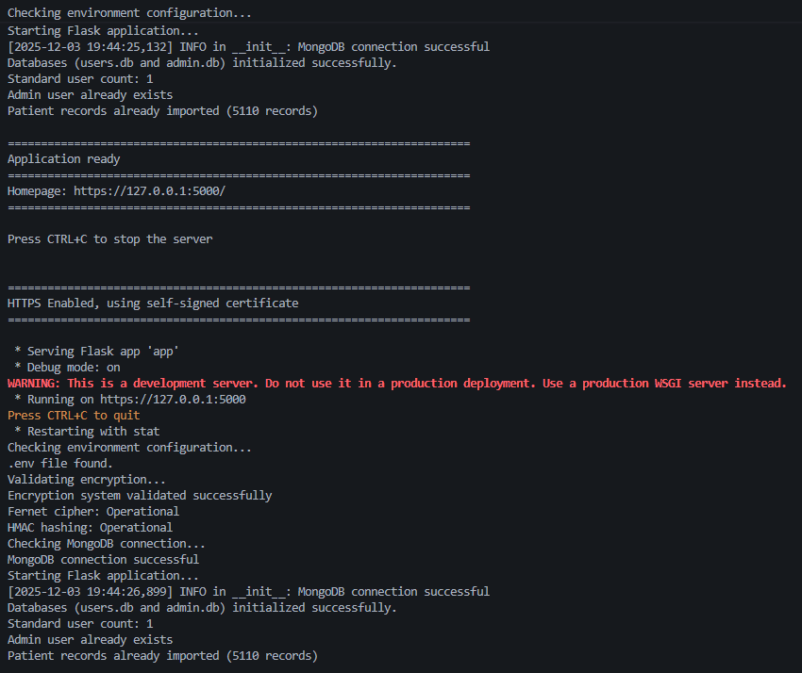

The terminal output will indicate that it has either created new environment settings, user and admin SQLlite databases or if previous ones exist it will load with them, and found a working connection to cloud atlas mongoDB or not. The red warning text is accurate, if running this application for production some settings and additional hosting would need to be taken into consideration.
When the “Main.py” script creates both SQL databases for users and admin, it also includes audit logging to them too. Each action of “CRUD” (Create, Read, Update, Delete) either an admin or user performs will leave an audit trail for accountability and transparency. Additionally a scheduler is set to automatically create backups of the user, admin, audit logs and mongoDB databases every 24 hours.
In production, periodic deletion and secure storage of these archives would be preferable however the sensitive, important and identifiable data of passwords for example are encrypted at rest meaning that the archives do have some level of protection even if were to be stored insecurely.

Once the web app is initialised and running, the terminal output will indicate the localhost address you will need to input into a browser of your choice to access the app. Once there, the browser may give a warning indicating that the site is not secure, click that you understand the risks and wish to proceed. This is due to the use of self-certification HTTPS connection, which is not advisable for production however during development it is an efficient approach to testing the validity of the encrypted connection afford with HTTPS.
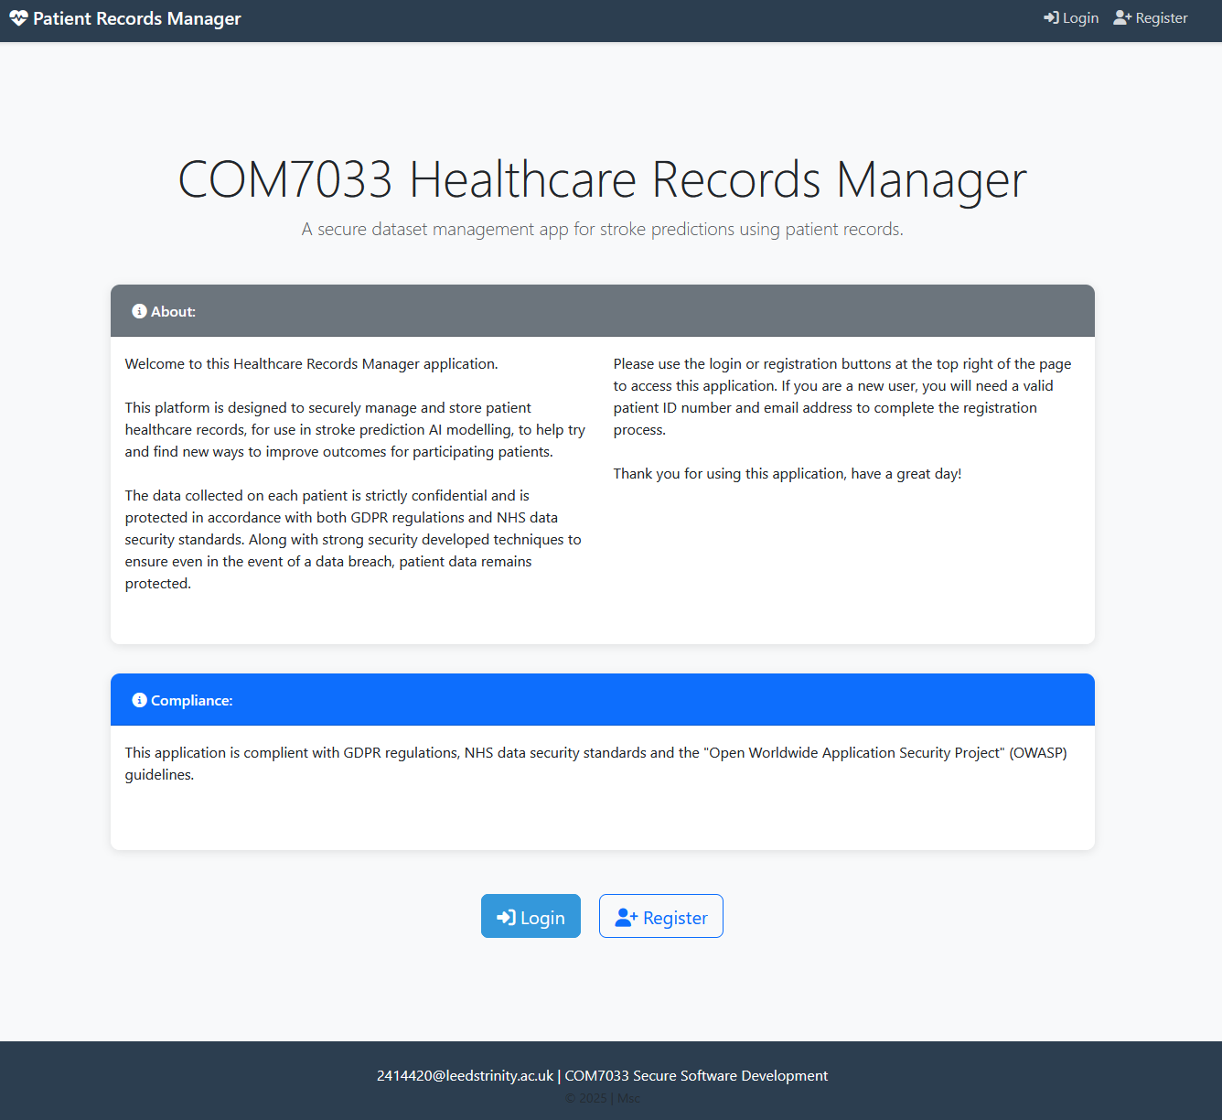Once at the homepage you will be greeted with the splash screen bellow:
To access the app, you will need to click on the “login” or “registration” buttons in the top right of the page or bellow. When the web app was initialised it used the “healthcare-dataset-stroke-data.csv” provided in the root directory to populate the mongoDB database with patient records, you will need to open that .csv with notepad and locate a patient ID number such as “9046” to register as a new user, or use the admin login information that was initially create inside the “Admin_Login,txt” in the root folder.
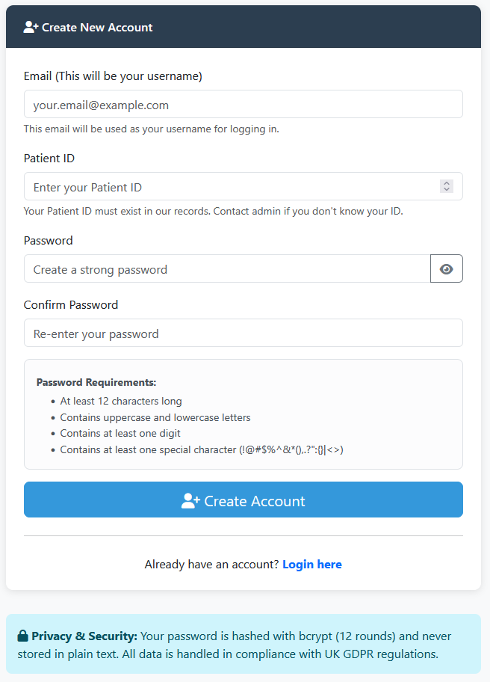When registering you will not be able to register as an admin user, only one admin account has been created during the initialisation process and remains the only one. As a user, you will be asked for an email address (which will become your login username), a “Patient ID” number which as mentioned must match for association with the database. And a password, with strong password conditions and a second password field to make sure the user did not input a typo by mistake and should remember their password.
Once completed the user will have their email address/username associate with their patient ID, and be greeted with a dashboard, where they will be able to perform “CRUD” operations on all of their information pertaining to their patient record except for their patient ID number by clicking on the “Edit My Record”. Or they can go to their account settings to change/update their password or email address by clicking on the “Account Settings” button.
The users may also return to this dashboard at any time by using the “My Records” button on the banner (at the top right of the page) or logging out with the drop down accessible by clicking on their user name.
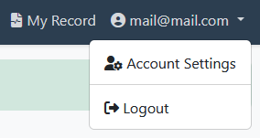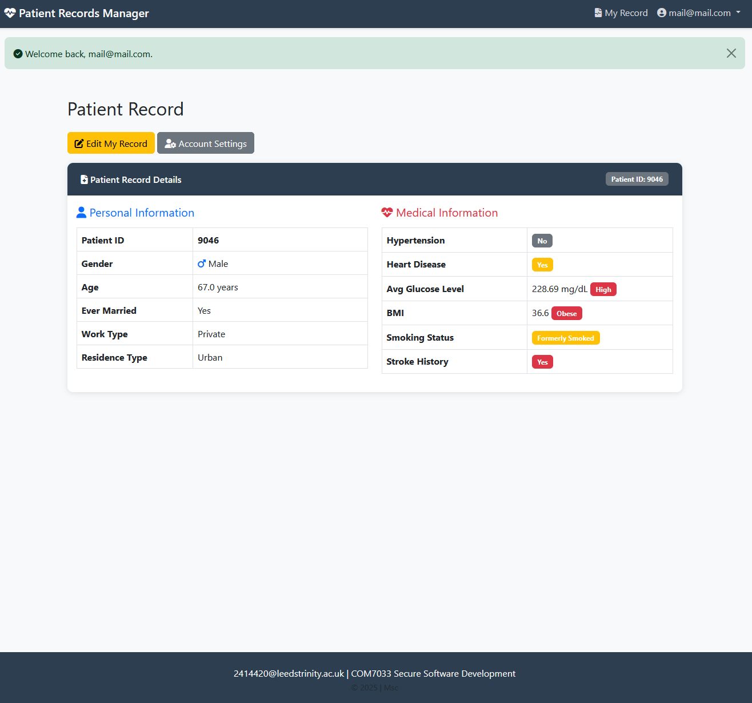

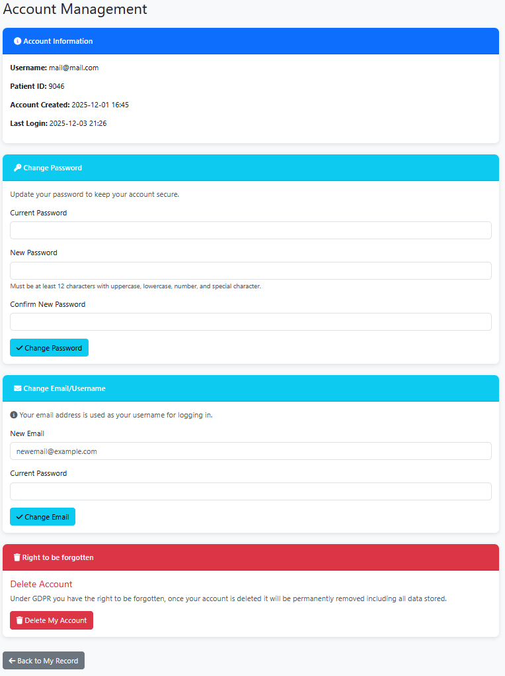When the user is at their account settings page they also have the option to delete their entire account along with all associated information. This will delete permanently all information the web app has collected on the user in question, along with their patient ID number (Per GDPR compliance).
A popup box will appear requiring further action to confirm deletion and affirm its permanence.

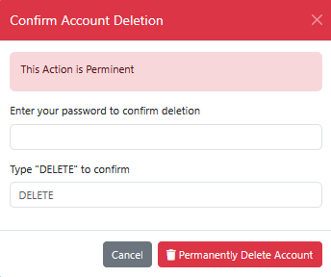

The admin account settings conversely, looks the same except for the absence of account deletion and the addition of two factor authentication” (2FA), which will be activated automatically once the admin saves an email address where the 2FA code will be sent to once required for log in. The admin should also change the passwords immediately or delete the “Admin_Login.txt” in the root folder if the web app is being used in a production setting for security reasons.
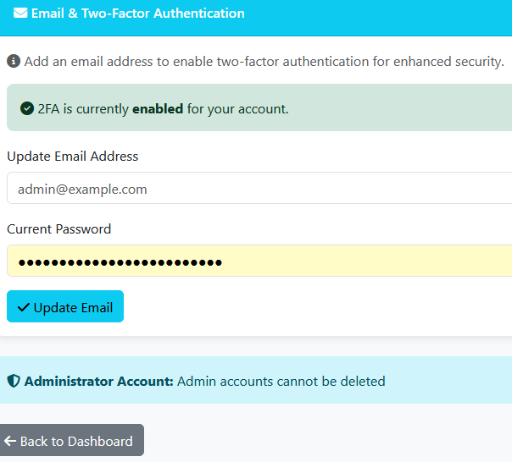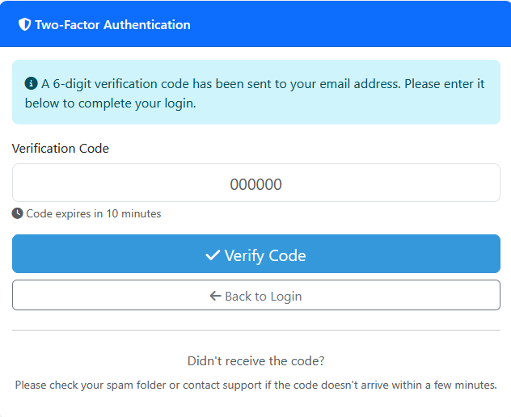The 2FA code is also sent to the “Admin_Login.txt” file and updated on each request by default as well as being sent to the email address saved. This however will not occur if the web app’s development settings have been changed to production (“FLASK_ENV=development” set to “FLASK_ENV=production”), which can be done by either manually changing the “.env” file located in the root directory, or by altering the .env creation settings in “Main.py” starting at line 39.

When the Admin log’s in initially past 2FA, they will be greeted by their unique dashboard that users will not have access too. This dashboard has multiple visualisations down the left panel showing patient record data distribution and statistics, including the overall performance and accuracy of the patient stroke prediction AI model.
In the centre are the records themselves with page numbers at the very bottom of the page. Each record in the list can be edited, viewed or deleted manually by the admin (the far right column), with each column displaying the recorded patients data. Above this is a search and filter panel allowing the admin to query the entire dataset for individual patients or subset of data features.
Next to this, about the visualisations on the left are the buttons for admin account settings and “New Patient Record” where the admin can manually add additional patients to the database which will also be automatically encrypted and handled in the same way the other records are.
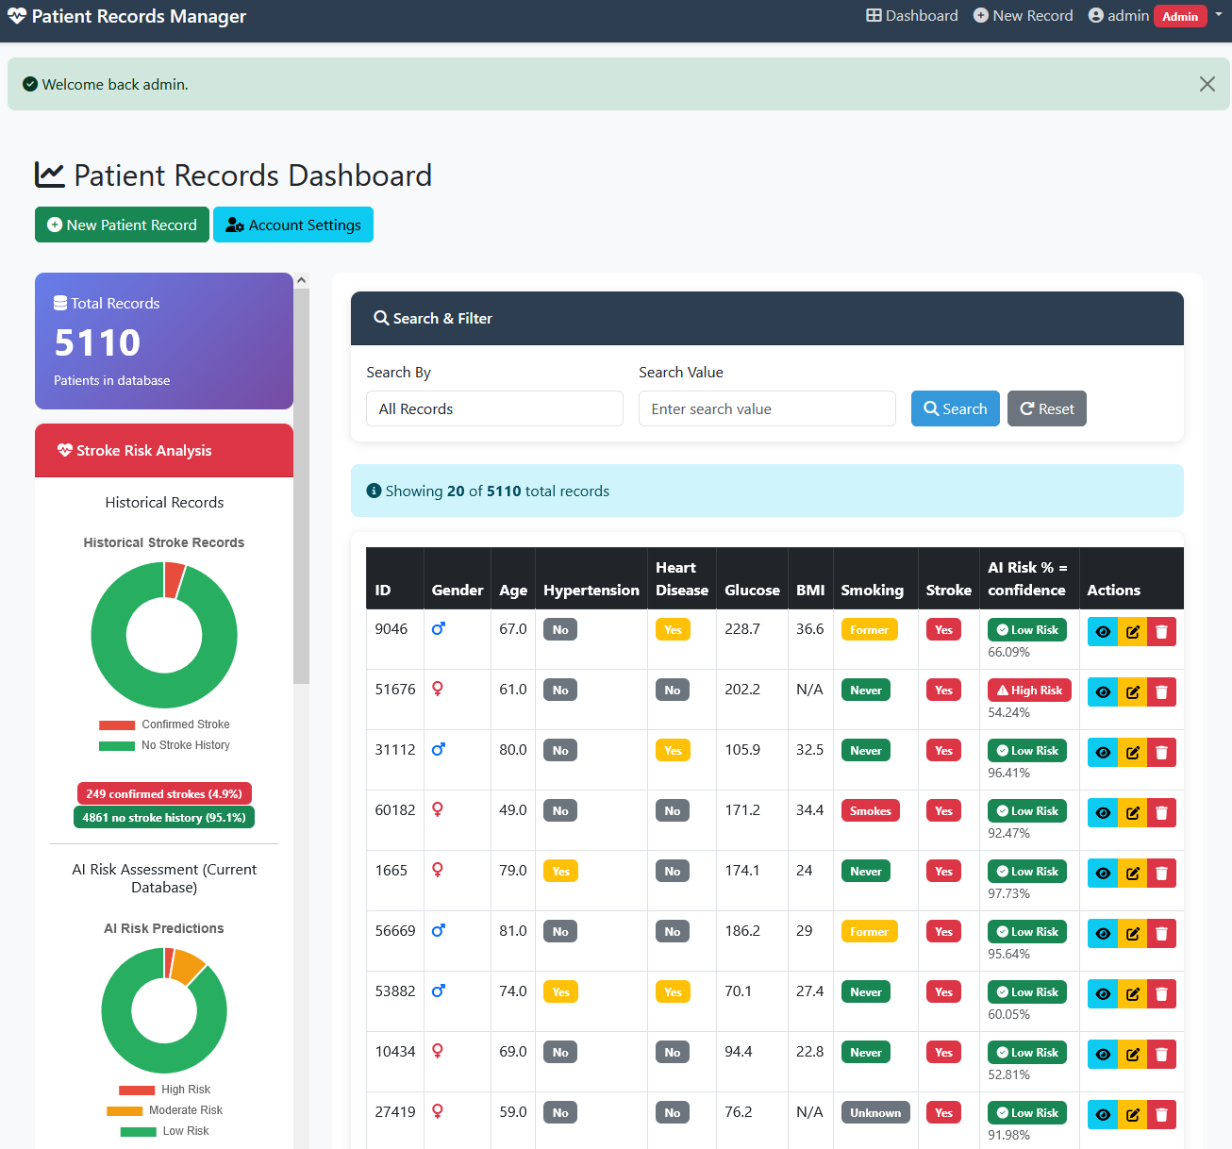
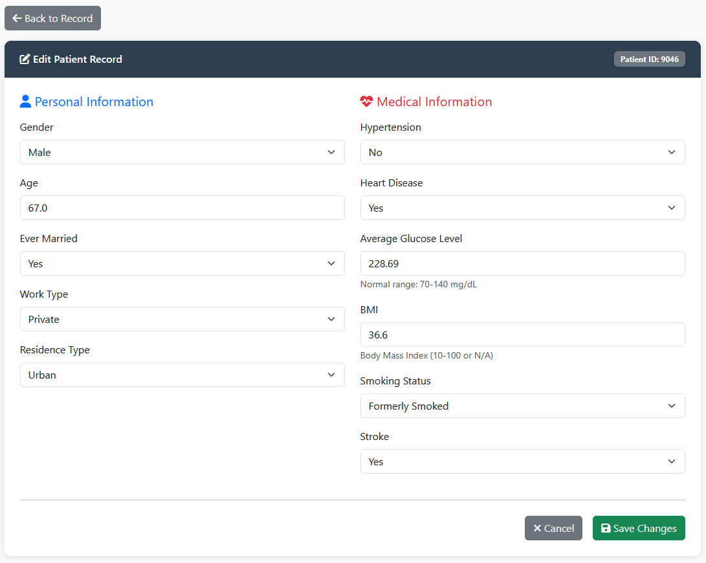

The data in the database is all encrypted using the “cryptography” python library, then when it is decrypted at runtime for the user’s browser which only connects over HTTPS, with (additional precautions, for session handling, CSRF Protection etc) the user may see the unencrypted information.
The search and filter functionality works similarly, as each searchable encrypted field has a “Hash-based Message Authentication Code” (HMAC) generated string associated with it. While the encrypted data is not searchable as each time it is encrypted the string generated would be different, ensuring it is extremely unlikely to decipher and therefore not deterministic. The associated HMAC however is deterministic and represents no data other than its association, meaning that it can be searchable in the dataset allowing fields to be found with plaintext.
Example fields of data stored in mongoDB, connected with “mongoDB Compass”
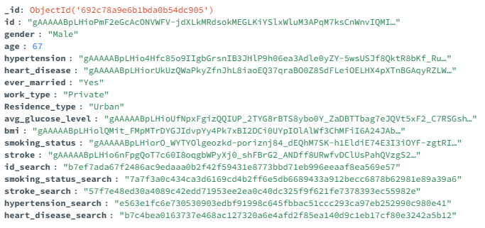

The AI model in the app can be re-trained at any point for better accuracy by returning to the chosen method of running python code, and executing the script called “train_svm_model.py” this will run the “DataProcessing.py” module followed by the “SVMmodel.py” and then save the weights and biases as a model file called “svm_stroke_model.pkl” to the root project location which is used at runtime for the patient records predictions.
The “DataProcessing.py” module takes all the currently existing records from the mongoDB database, decrypts it using “security.py” and performs the other required dataset cleaning and processing steps to improve the models efficiency. From there the “SVMmodel.py” module is able to take that processed dataset and train for weights and biases before running performance metrics and exporting the completed model for use.
The choice of AI model to use was selected from the best performing models found from a relatively recent literature review on the subject ( (Biswas et al., 2022), (Asadi et al., 2024)), with care taken to follow closely any mention of design details and changed where appropriate to best accommodate for the difference in datasets used. For instance the hyper parameter grid search fits in the reference paper is much higher as the dataset they trained the model on was much higher and would likely cause over fitting on this projects much smaller dataset.
For the testing of the app, it would be best to use an IDE such as “VScode“ to run all the unit tests, opening the project’s root folder in VScode with the python extension installed. Navigate to the left side panel and select the testing icon that looks like a lab flask, from there clicking on the small right facing arrow that appears when hovering the mouse over the top listed item bellow the total listed number of tests that says “run test”.
This should run all 143 of the automatically compiled list of unit tests included in the project, a more detailed breakdown of each unit test module is included in the code comments inside the “tests” folder found in the root directory. In summary there are unit tests for the majority of the web apps functionality and specifically for each of the security features, ideally the unit tests are run before the web app is run and prevented from running if there are failures.
Additionally, there is an included “.yml” file in the “.github” folder in the root directory that will run the unit tests as part of “github actions” which also includes a “Static Automated Security Testing” (SAST) report generated from the “bandit” python library.
The SAST report, along with a manual “Dynamic Automated Security Test” (DAST) test report conducted with OWASP’s “ZAP” utility was compiled inside the folder called “SAST and DAST reports” in the root directory (more information can be found about how to use, install and test with ZAP here: https://www.zaproxy.org/).

